**Write and submit R code to solve the following. Also comment on findings.**

**1. University Hospital has been concerned with the number of errors found in its billing statements to patients. An audit of 100 bills per week over the past 12 weeks revealed the following number of errors:**

|  |  |
| --- | --- |
| **Week** | **Number of errors** |
| **1** | **4** |
| **2** | **5** |
| **3** | **6** |
| **4** | **6** |
| **5** | **3** |
| **6** | **2** |
| **7** | **6** |
| **8** | **7** |
| **9** | **3** |
| **10** | **4** |
| **11** | **4** |
| **12** | **4** |

**(a) Develop suitable control chart (use 3σ control limits).**

**(b) Is the process in control?**

C-charts can be used to monitor the number of errors per week.

Z-value for control charts = 3

Let c = number of errors

The average number of errors per week 

Control limits of chart are as follows:

CL = 4.5





Since the number of complaints cannot be negative, **LCL = 0**

**R Script :**

#install.packages("qcc") ## installation of qcc package

library**(**qcc**)** ## load qcc library

set.seed**(**111**)** ## set seed for reproducing same results

x **<-** c**(**4, 5, 6, 6, 3, 2, 6, 7, 3, 4, 4, 4**)**

## Number of errors of 12 weeks

obj **<-** qcc**(** data **=** x,

type**=**"c", ## plots c-chart

nsigmas **=** 3, ## 3-sigma control

xlab **=** "Week", ## labels

ylab **=** "No. of errors",

title **=** "C Chart for No. of errors of 12 weeks"**)**

summary**(**obj**)**

# Summary of group statistics:

# Min. 1st Qu. Median Mean 3rd Qu. Max.

# 2.00 3.75 4.00 4.50 6.00 7.00

#

# Group sample size: 1

# Number of groups: 12

# Center of group statistics: 4.5

# Standard deviation: 2.12132

#

# Control limits:

# LCL UCL

# 0 10.86396

plot**(**obj**)**

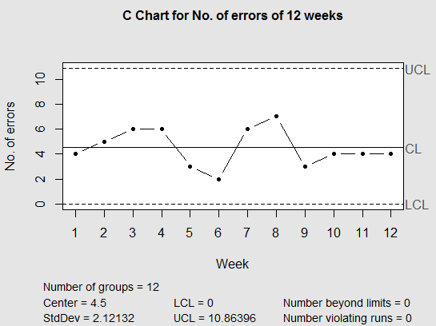

From the above control chart, we can clearly see that number of errors are within the control limits (UCL, LCL).

So, we can conclude that the process is in control.

**2. XYZ Toothpaste Company makes tubes of toothpaste. The product is produced and then pumped into tubes and capped. The production manager is concerned whether the filling process for the tubes of toothpaste is in statistical control. The process should be centered on 6 ounces per tube. Six samples of 5 tubes were taken and each tube was weighed. The weights are:**

|  |  |  |  |  |  |
| --- | --- | --- | --- | --- | --- |
|  | **Ounces of tooth paste per tube** | | | | |
| **Sample** | **1** | **2** | **3** | **4** | **5** |
| **1** | 5.78 | 6.34 | 6.24 | 5.23 | 6.12 |
| **2** | 5.89 | 5.87 | 6.12 | 6.21 | 5.99 |
| **3** | 6.22 | 5.78 | 5.76 | 6.02 | 6.10 |
| **4** | 6.02 | 5.56 | 6.21 | 6.23 | 6.00 |
| **5** | 5.77 | 5.76 | 5.87 | 5.78 | 6.03 |
| **6** | 6.00 | 5.89 | 6.02 | 5.98 | 5.78 |

**(a) Develop a control chart for the mean and range for the available toothpaste data (use 3σ control limits).**

**(b) Plot the observations on the control chart and comment on your findings.**

|  |  |  |  |  |  |  |  |
| --- | --- | --- | --- | --- | --- | --- | --- |
|  | **Ounces of tooth paste per tube** | | | | |  |  |
| **Sample** | **1** | **2** | **3** | **4** | **5** | **Mean** | **Range** |
| **1** | 5.78 | 6.34 | 6.24 | 5.23 | 6.12 | 5.942 | 1.11 |
| **2** | 5.89 | 5.87 | 6.12 | 6.21 | 5.99 | 6.016 | 0.34 |
| **3** | 6.22 | 5.78 | 5.76 | 6.02 | 6.10 | 5.976 | 0.46 |
| **4** | 6.02 | 5.56 | 6.21 | 6.23 | 6.00 | 6.004 | 0.67 |
| **5** | 5.77 | 5.76 | 5.87 | 5.78 | 6.03 | 5.842 | 0.27 |
| **6** | 6.00 | 5.89 | 6.02 | 5.98 | 5.78 | 5.934 | 0.24 |
|  |  |  |  |  | Mean: | 5.9523 | 0.515 |

Z-value for control charts = 3

, , n = 5

Control Limits for Xbar Chart,

CL = 5.9523





Control Limits for R-Chart,

CL = 5.9523





**R Script :**

tube1 **<-** c**(**5.78, 5.89, 6.22, 6.02, 5.77, 6.00**)**

tube2 **<-** c**(**6.34, 5.87, 5.78, 5.56, 5.76, 5.89**)**

tube3 **<-** c**(**6.24, 6.12, 5.76, 6.21, 5.87, 6.02**)**

tube4 **<-** c**(**5.23, 6.21, 6.02, 6.23, 5.78, 5.98**)**

tube5 **<-** c**(**6.12, 5.99, 6.10, 6.00, 6.03, 5.78**)**

df **=** data.frame**(**tube1, tube2, tube3, tube4, tube5**)**

############################ Xbar Chart ######################################

objx **<-** qcc**(**data **=** df,

type **=** "xbar",

nsigmas **=** 3, ## 3-sigma control

xlab **=** "Tube", ## labels

ylab **=** "Ounces of toothpaste per tube",

title **=** "Mean-Control Chart (Xbar)for\nOunces of toothpaste per tube"**)**

summary**(**objx**)**

# Summary of group statistics:

# Min. 1st Qu. Median Mean 3rd Qu. Max.

# 5.842000 5.936000 5.959000 5.952333 5.997000 6.016000

#

# Group sample size: 5

# Number of groups: 6

# Center of group statistics: 5.952333

# Standard deviation: 0.2214101

#

# Control limits:

# LCL UCL

# 5.65528 6.249386

plot**(**objx**)**

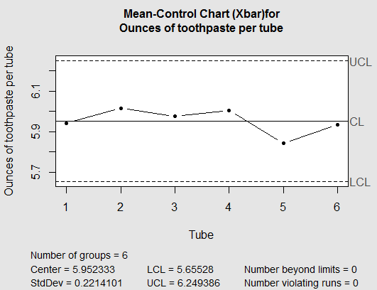

There is no point outside the control limits.

The process mean is in control.

############################ R Chart ######################################

objr **<-** qcc**(**data **=** df,

type **=** "R",

nsigmas **=** 3, ## 3-sigma control

xlab **=** "Tube", ## labels

ylab **=** "Ounces of toothpaste per tube",

title **=** "Range-Control Chart (R) for\nOunces of toothpaste per tube"**)**

summary**(**objr**)**

# Summary of group statistics:

# Min. 1st Qu. Median Mean 3rd Qu. Max.

# 0.2400 0.2875 0.4000 0.5150 0.6175 1.1100

#

# Group sample size: 5

# Number of groups: 6

# Center of group statistics: 0.515

# Standard deviation: 0.2214101

#

# Control limits:

# LCL UCL

# 0 1.088952

plot**(**objr**)**

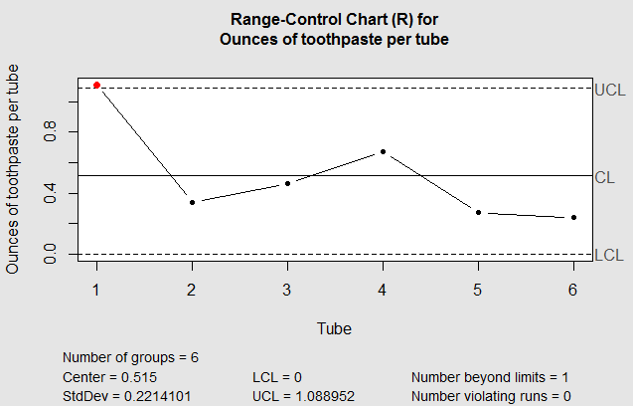

Sample 1 record is outside UCL.

The process range is not in control.

**3. A quality control manager at a manufacturing facility has taken 4 samples with 4 observations each of the diameter of a part.**

|  |  |  |  |
| --- | --- | --- | --- |
| **Sample of part diameter in inches** | | | |
| **1** | **2** | **3** | **4** |
| 5.8 | 6.2 | 6.1 | 6.0 |
| 5.9 | 6.0 | 5.9 | 5.9 |
| 6.0 | 5.9 | 6.0 | 5.9 |
| 6.1 | 5.9 | 5.8 | 6.1 |

**(a) Develop suitable control limits for 3σ of the product diameter.**

**(b) Comment on your findings.**

|  |  |  |  |  |
| --- | --- | --- | --- | --- |
| **Sample of part diameter in inches** | | | |  |
| **1** | **2** | **3** | **4** | **Mean** |
| 5.8 | 6.2 | 6.1 | 6.0 | 5.95 |
| 5.9 | 6.0 | 5.9 | 5.9 | 6 |
| 6.0 | 5.9 | 6.0 | 5.9 | 5.95 |
| 6.1 | 5.9 | 5.8 | 6.1 | 5.975 |
| **Mean of the sampling distribution =** | | | | 5.97 |

n = 16

The mean of the sampling distribution is the average of the sample means, i.e.



The population standard deviation  can be estimated from the 4 samples using the= 0.1138347

The standard deviation of the sampling distribution is computed as 

Control Limits for Xbar Chart,

CL = 5.97

UCL = 6.14

LCL = 5.80

**R Script :**

sample1 **<-** c**(**5.8, 5.9, 6.0, 6.1**)**

sample2 **<-** c**(**6.2, 6.0, 5.9, 5.9**)**

sample3 **<-** c**(**6.1, 5.9, 6.0, 5.8**)**

sample4 **<-** c**(**6.0, 5.9, 5.9, 6.1**)**

df **=** data.frame**(**sample1, sample2, sample3, sample4**)**

obj **<-** qcc**(**data **=** df,

type **=** "xbar",

nsigmas **=** 3, ## 3-sigma control

xlab **=** "Sample", ## labels

ylab **=** "Part Diameter in inches",

title**=** "Mean-Control Chart (Xbar)for\ndiameter of a part"**)**

summary**(**obj**)**

# Summary of group statistics:

# Min. 1st Qu. Median Mean 3rd Qu. Max.

# 5.92500 5.94375 5.96250 5.96875 5.98750 6.02500

#

# Group sample size: 4

# Number of groups: 4

# Center of group statistics: 5.96875

# Standard deviation: 0.1092763

#

# Control limits:

# LCL UCL

# 5.804835 6.132665

plot**(**obj**)**

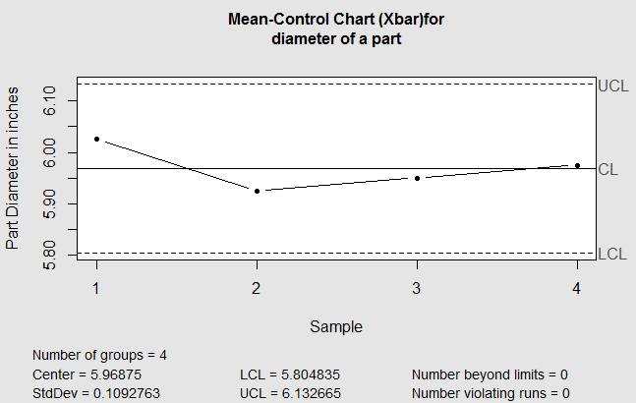

From above control chart, it is very clear that none of the point is outside control limits.

Hence the process is under control.

**4. A production manager at Ultra Clean Dishwashing Company is monitoring the quality of the company’s production process. There has been concern relative to the quality of the operation to accurately fill the 16 ounces of dishwashing liquid. The company collected the following sample data on the production process:**

|  |  |  |  |  |
| --- | --- | --- | --- | --- |
|  | **Observations** | | | |
| **Sample** | **1** | **2** | **3** | **4** |
| **1** | 16.40 | 16.11 | 15.90 | 15.78 |
| **2** | 15.97 | 16.10 | 16.20 | 15.81 |
| **3** | 15.91 | 16.00 | 16.04 | 15.92 |
| **4** | 16.20 | 16.21 | 15.93 | 15.95 |
| **5** | 15.87 | 16.21 | 16.34 | 16.43 |
| **6** | 15.43 | 15.49 | 15.55 | 15.92 |
| **7** | 16.43 | 16.21 | 15.99 | 16.00 |
| **8** | 15.50 | 15.92 | l6.12 | 16.02 |
| **9** | 16.13 | 16.21 | 16.05 | 16.01 |
| **10** | 15.68 | 16.43 | 16.20 | 15.97 |

**(a) Are the process mean and range in statistical control?**

**(b) Do you think this process is capable of meeting the design standard? Also Comment on your findings.**

|  |  |  |  |  |  |  |
| --- | --- | --- | --- | --- | --- | --- |
|  | **Observations** | | | |  |  |
| **Sample** | **1** | **2** | **3** | **4** | **Mean** | **Range** |
| **1** | 16.40 | 16.11 | 15.90 | 15.78 | 16.05 | 0.62 |
| **2** | 15.97 | 16.10 | 16.20 | 15.81 | 16.02 | 0.39 |
| **3** | 15.91 | 16.00 | 16.04 | 15.92 | 15.97 | 0.13 |
| **4** | 16.20 | 16.21 | 15.93 | 15.95 | 16.07 | 0.28 |
| **5** | 15.87 | 16.21 | 16.34 | 16.43 | 16.21 | 0.56 |
| **6** | 15.43 | 15.49 | 15.55 | 15.92 | 15.60 | 0.49 |
| **7** | 16.43 | 16.21 | 15.99 | 16.00 | 16.16 | 0.44 |
| **8** | 15.50 | 15.92 | l6.12 | 16.02 | 15.89 | 0.62 |
| **9** | 16.13 | 16.21 | 16.05 | 16.01 | 16.10 | 0.20 |
| **10** | 15.68 | 16.43 | 16.20 | 15.97 | 16.07 | 0.75 |
|  |  |  |  | Mean: | 16.01 | 0.45 |

Z-value for control charts = 3

, , n = 4

Control limits for Xbar chart:

CL = 16.01





Control Limits for R-chart:

CL = 0.45





**R Script :**

sample1 **<-** c**(**16.4, 15.97, 15.91, 16.2, 15.87, 15.43, 16.43, 15.50, 16.13, 15.68**)**

sample2 **<-** c**(**16.11, 16.10, 16.00, 16.21, 16.21, 15.49, 16.21, 15.92, 16.21, 16.43**)**

sample3 **<-** c**(**15.9, 16.2, 16.04, 15.93, 16.34, 15.55, 15.99, 16.12, 16.05, 16.20**)**

sample4 **<-** c**(**15.78, 15.81, 15.92, 15.95, 16.43, 15.92, 16, 16.02, 16.01, 15.97**)**

df **=** data.frame**(**sample1, sample2, sample3, sample4**)**

############################ Xbar Chart ######################################

objx **<-** qcc**(**data **=** df,

type **=** "xbar",

nsigmas **=** 3, ## 3-sigma control

xlab **=** "Sample", ## labels

ylab **=** "Ounces of Dishwashing Liquid",

title**=** "Mean-Control Chart (Xbar)for\nOunces of Dishwashing Liquid"**)**

summary**(**objx**)**

# Summary of group statistics:

# Min. 1st Qu. Median Mean 3rd Qu. Max.

# 15.59750 15.98062 16.05875 16.01350 16.09313 16.21250

#

# Group sample size: 4

# Number of groups: 10

# Center of group statistics: 16.0135

# Standard deviation: 0.2175814

#

# Control limits:

# LCL UCL

# 15.68713 16.33987

plot**(**objx**)**

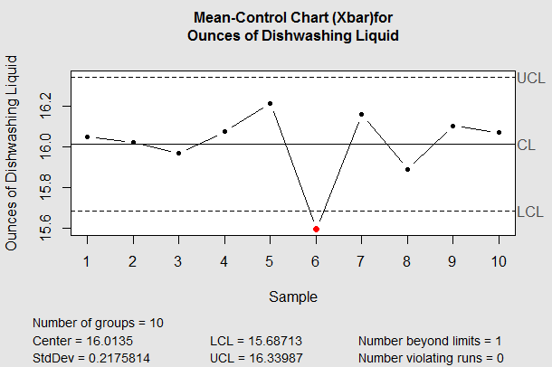

Sample 6 record is out of LCL.

The process mean is not in control.

############################ R Chart ######################################

objr **<-** qcc**(**data **=** df,

type **=** "R",

nsigmas **=** 3, ## 3-sigma control

xlab **=** "Sample", ## labels

ylab **=** "Ounces of Dishwashing Liquid",

title**=** "Range-Control Chart (R)for\nOunces of toothpaste per tube"**)**

summary**(**objr**)**

# Summary of group statistics:

# Min. 1st Qu. Median Mean 3rd Qu. Max.

# 0.1300 0.3075 0.4650 0.4480 0.6050 0.7500

#

# Group sample size: 4

# Number of groups: 10

# Center of group statistics: 0.448

# Standard deviation: 0.2175814

#

# Control limits:

# LCL UCL

# 0 1.022291

plot**(**objr**)**

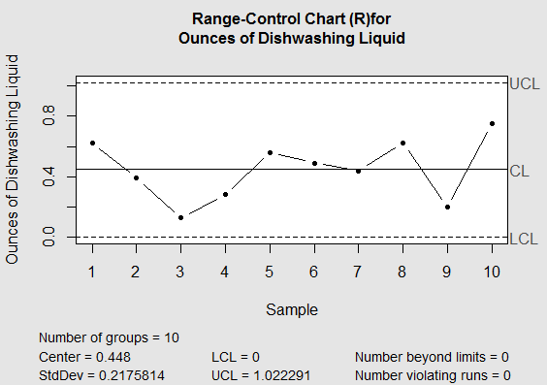

The process range is in control.

The process is not capable of meeting the design standards.

Design standards dictate that fill levels range between 16.3 ounces and 15.7.

There are nine observations that do not fall in this range.